Name = Muhammad Daniyal

Registration no = 24371
Submitted to : Mam Fariyal

Software Construction and Development CA

Lab 6

Lab Tasks
Task 1: Reverse a String
Take a string from user and print it in reverse.

Output:
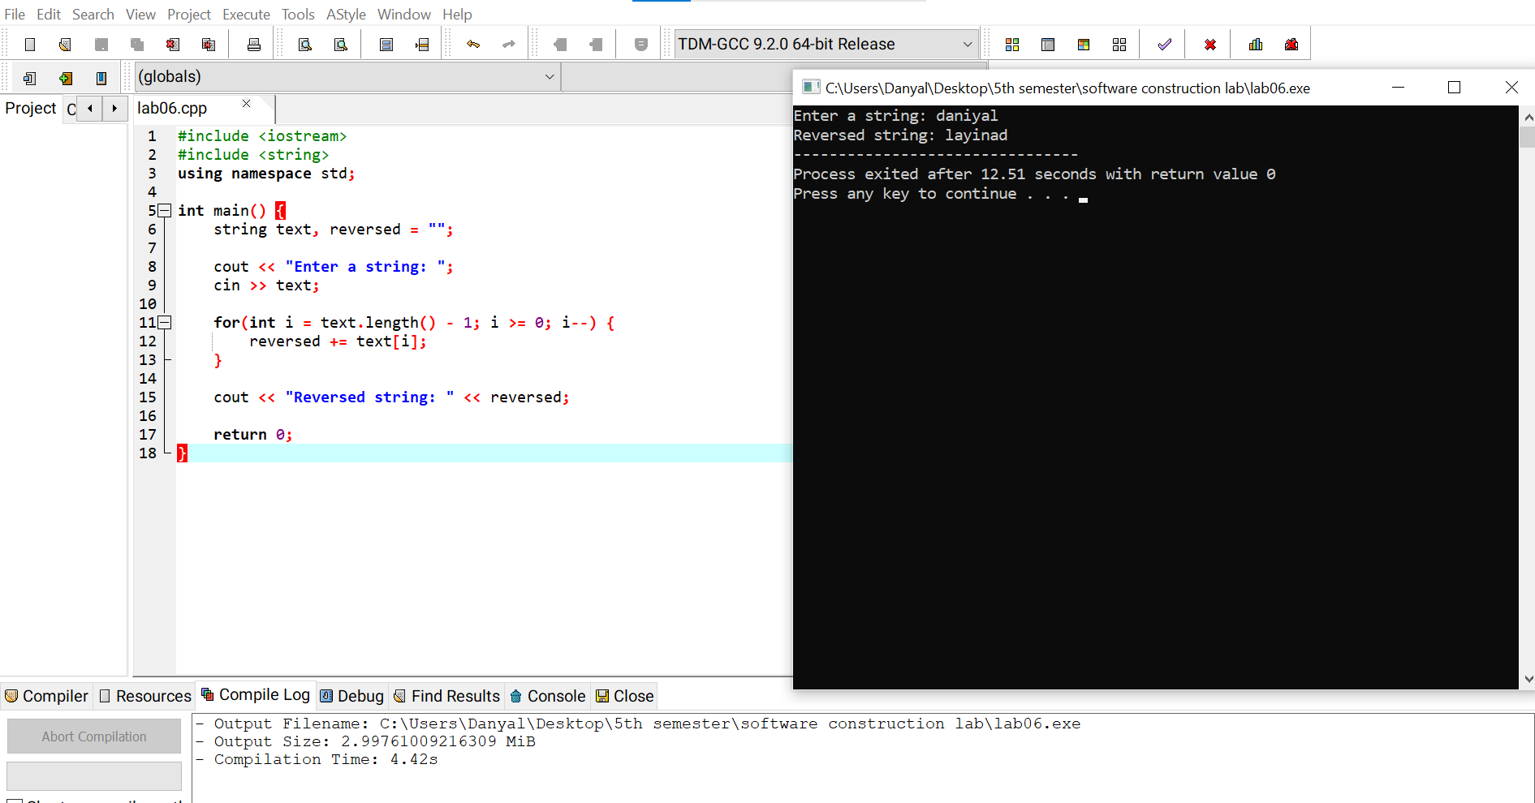
Task 2: Count Characters
Print total number of characters in a string using: length()
Output:
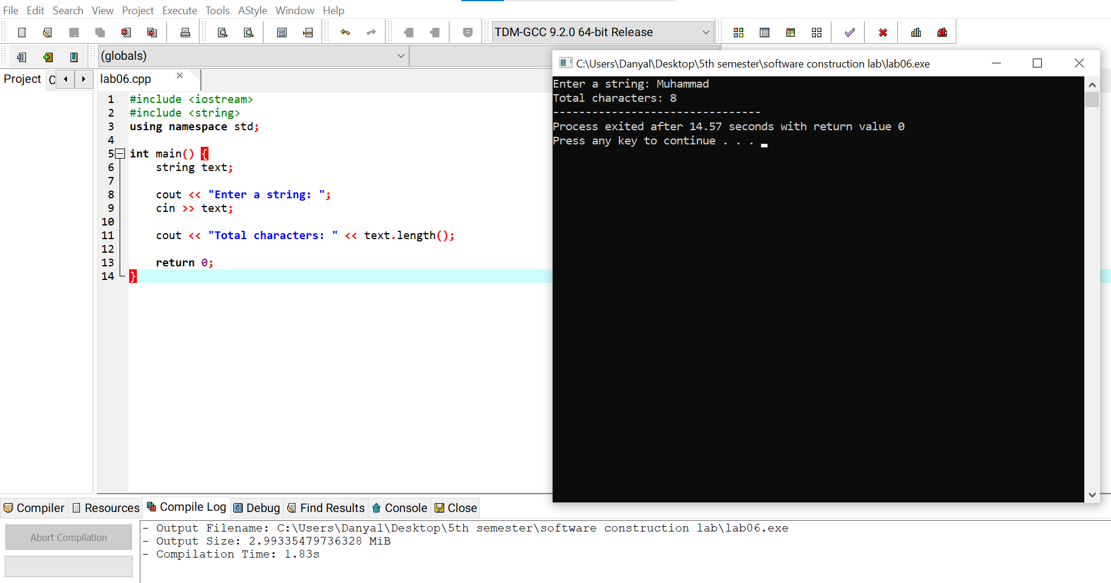
Task 3: Convert to Uppercase
Convert entire string into uppercase. Hint:
Use toupper().
Output:
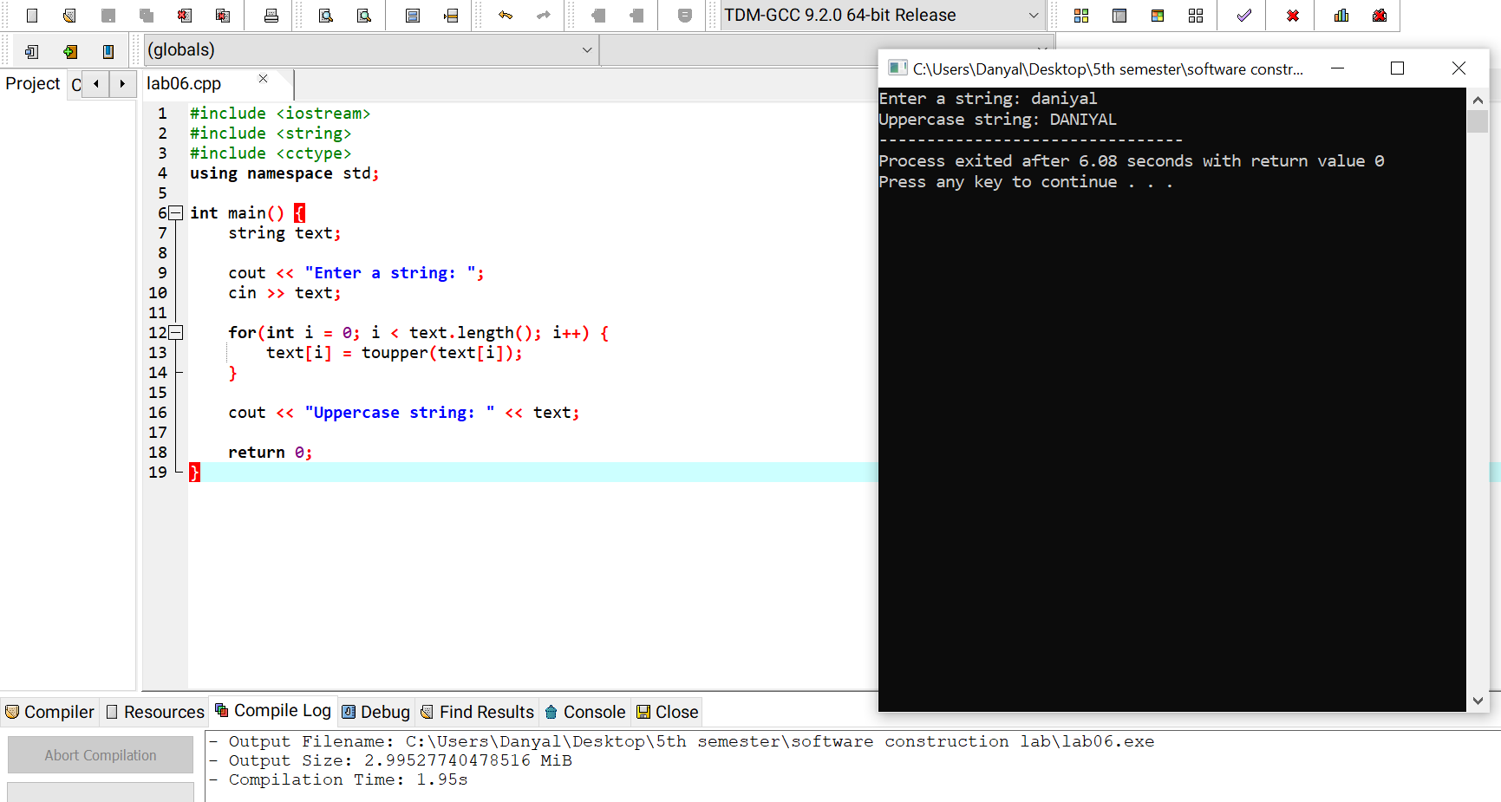

Task 4: Check First and Last Character Check whether first and last character are same.
Output:
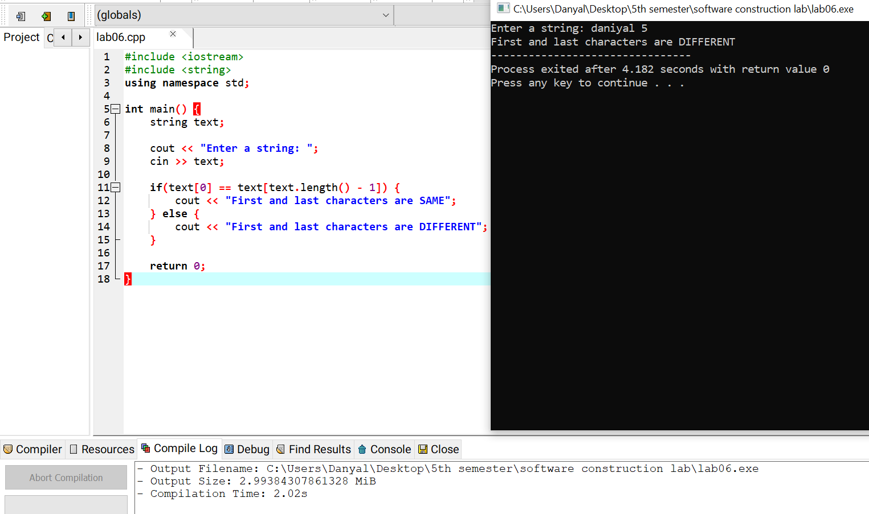
Task 5: Concatenate Two Strings
Take two names and combine them into one full name. Example:
Ali + Khan = Ali Khan
Output:
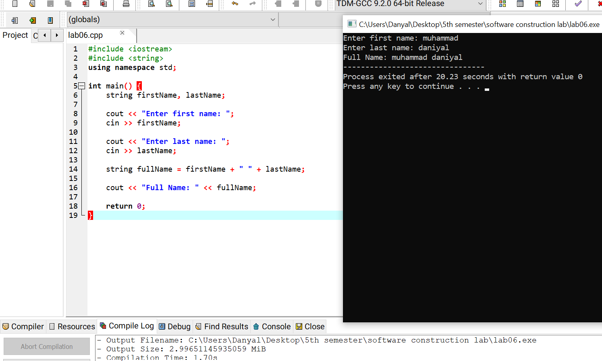

The End

